**Task - 4**

**Name** :Sujitra M

**Email ID** : [sujiedusport@gmail.com](mailto:sujiedusport@gmail.com)

**Task Title**: OTT Platform Website Clone

**Task Description**:

The Fourth task involves developing a OTT Platform Website Clone using HTML, CSS and JavaScript. The web page includes a Home page and Content Details page. The primary goal is to utilize HTML, CSS and JavaScript to recreate the OTT Platform Website Clone and to design a user-friendly interface which is responsive across various devices. This task aims to test skills in front-end development and user interface design.

**Steps Taken:**

1. **HTML Structure:** Created the HTML structure ensuring semantic markup and accessibility standards. Used Various HTML tags to develop the layout of each element on a web page.
2. **CSS Styling:** Utilized CSS to style the HTML elements according to the design specifications including fonts, colors, backgrounds, spacing, pointer, border alignment.
3. **Responsive Design:** Implemented media queries, Grid and flexible layout techniques to ensure responsiveness across various devices and screen sizes.
4. **JavaScript:** Used JavaScript language to make web page interactive and execute complex actions. It allows us to dynamically update content without reloading the entire page and also used to create clickable Buttons, control multimedia.

**Challenges Faced:**

**Responsive Layout:** Adapting the design to ensure responsiveness across different devices posed a challenge, especially in handling complex layouts and interactions.

**Solutions Implemented:**

Media Queries, Grid and Flexbox Layout Module played a major role to make the web page responsive.

1. **Media Queries:** Implemented media queries to adjust layout and styling based on screen size, ensuring optimal display across devices.
2. **Grid Layout Module:** Implemented Grid Layout Module for space distribution.
3. **Flexbox Layout Module**: Implemented Flexbox Layout Module for arranging items in rows or columns. Flexbox offers space distribution between items and powerful alignment capabilities.

**Learnings:**

1. **HTML Structure:** Learned various HTML tag and its properties.
2. **CSS Techniques:** Learned advanced CSS techniques such as

* **Flexbox Layout Module**: Used Flexbox to streamline page structure and enhance responsiveness.
* **Grid Layout Module**: Also used Flexbox to streamline page structure and enhance responsiveness.
* **Media Queries:** Gained a deeper understanding of responsive design principles and techniques for creating adaptable layouts using Media Queries.
* **Transition:** Used Transition to change property values smoothly over a given duration
* **Text-Transform:** Used to specify uppercase and lowercase letters in a text.
* **Variable:** Used Variables to store and reuse the values and it makes the code more understandable
* **Position:** Used Position property to specify the position an element.

1. **JavaScript:** Learned various JavaScript concept like Objects, Properties, Events Functions, Loops, Closures, Switch Statement, HTML DOM Elements and Methods.

**Project Update:**

The OTT Platform Website Clone has been successfully developed. The web page is developed with Hyper Test Markup Language(HTML), Cascading Style Sheets(CSS) and JavaScript. The page is fully functional and responsive, showcasing the information effectively across various devices and screen sizes.

**Project Images:**

Home Page:

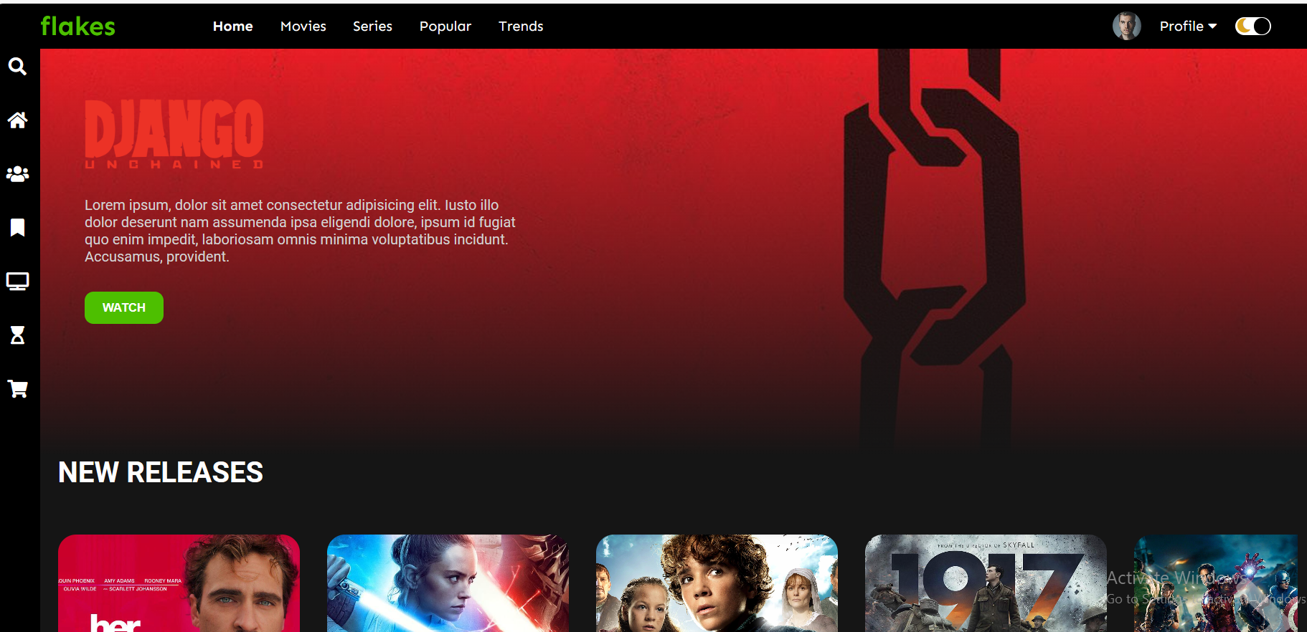

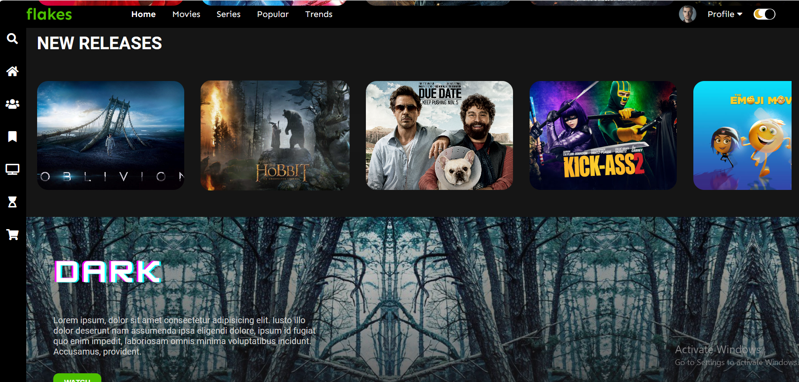

Content Details Page:

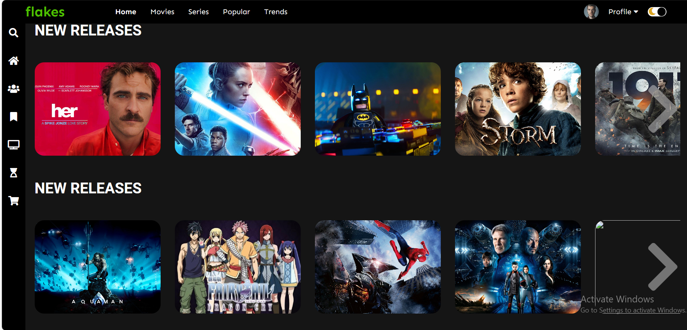

**Date: 13-04-2024**